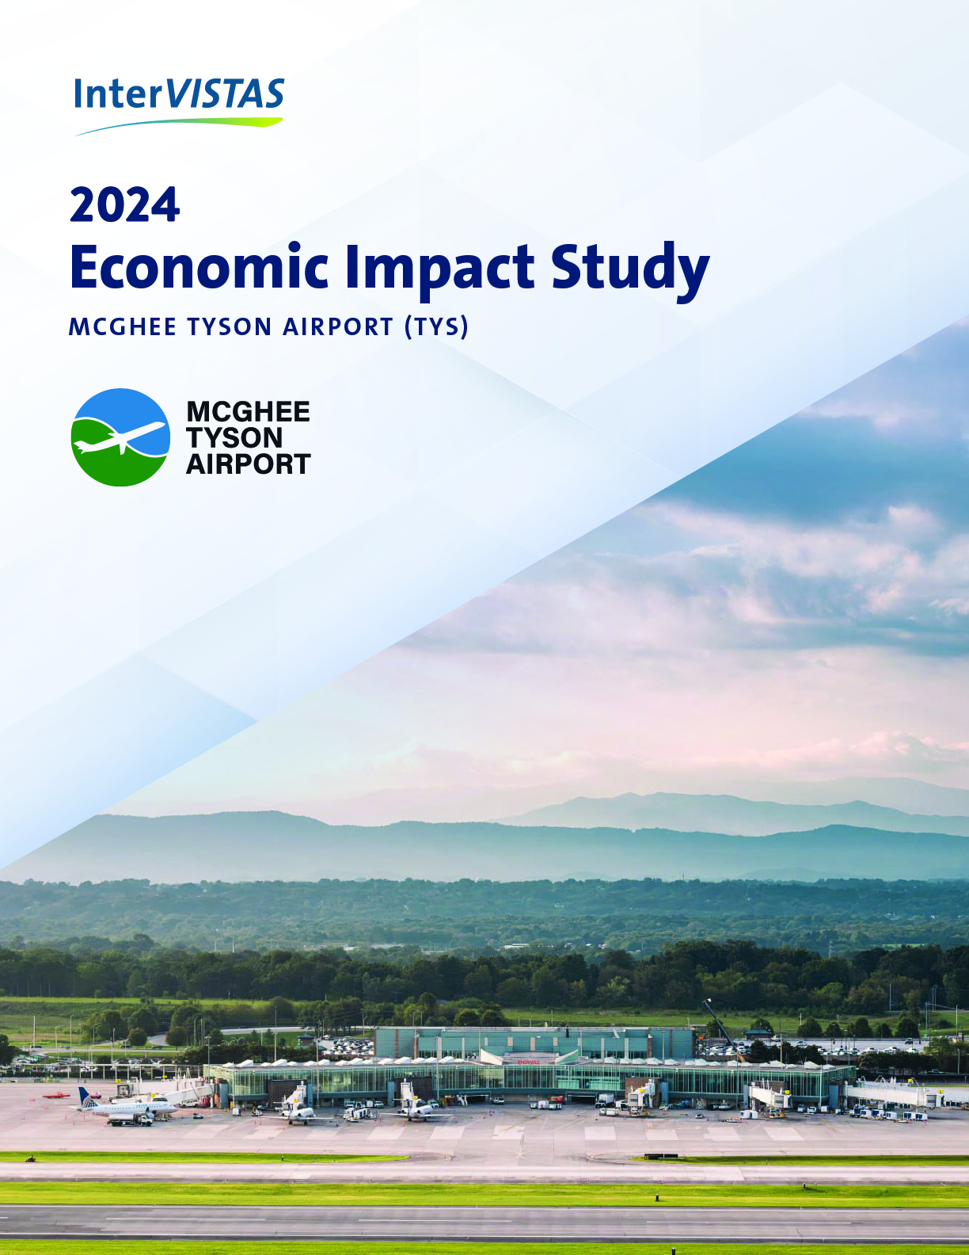

DRAFT REPORT – February 11, 2026

Executive Summary
This study provides the latest snapshot of McGhee Tyson Airport’s (TYS) annual economic contribution to the state of Tennessee, based on 2024 airport operations. Airports serve as vital economic engines by enabling the transit of individuals, commodities, and services across the country. They contribute to job creation and economic growth in local areas through various significant channels such as tourism, capital inflow, commerce of products and services, and enhancements in efficiency. The development of aviation operations and related activities facilitated by McGhee Tyson Airport has made it a robust economic generator for broader State of Tennessee.
The ongoing functions of TYS rely on an ecosystem of related businesses and organizations. This includes airlines and crew bases, cargo and logistics providers, ground handling services, air traffic control, security screening, aircraft maintenance and repair facilities, terminal retail and dining, and ground transportation. Economic activity is further stimulated by capital improvements, as well as the airport’s capacity to facilitate tourism and visitation to Knoxville and the State of Tennessee.
This study examined the economic impact of McGhee Tyson Airport for 2024.
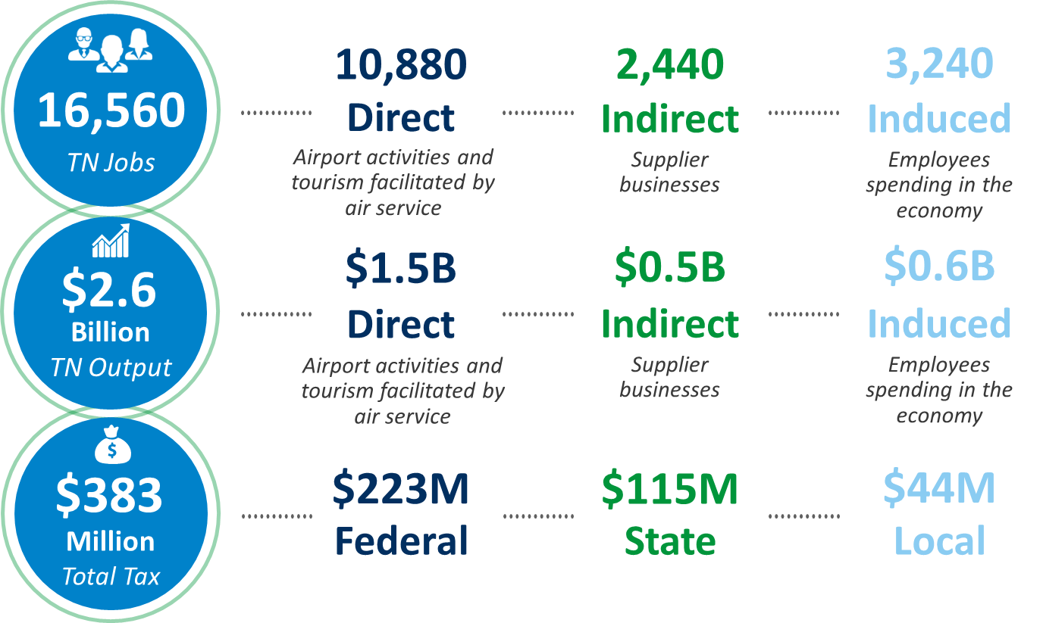
McGhee Tyson Airport is a key economic engine,
supporting over 16,500 jobs and $2.6 billion in economic output.
It also generates over $380 million in government revenues —
$233 million federal, $115 million state, and $44 million local taxes.

Airport operations, capital investments, and tourism businesses benefiting from visitor expenditures directly support 10,880 jobs, which go on to generate additional ripple effects in the economy.
Daily airport operations generate 3,300 direct jobs. Aviation-related suppliers and support businesses create 880 indirect jobs, and employee spending produces another 1,390 induced jobs in the general economy.

Airport capital improvements, with an estimated average annual in-state expenditure of $63 million, account for 440 direct jobs. Supplier impacts support 100 indirect jobs, and employee spending sustains another 170 induced jobs.
Visitor expenditures by non-local passengers flying via TYS, estimated at $873 million in 2024, facilitate 7,130 direct jobs. Supplier impacts create 1,470 indirect jobs, and spending by those employed directly or indirectly generates an additional 1,680 induced jobs.
Figure E-1: Consolidated Economic Impact of TYS, 2024
 |  |  |  |  | 
 | Impact | Employment  (Jobs) | Labor Income  ($ Millions) | GDP  ($ Millions) | Output  ($ Millions)
Airport Operations | Direct | 3,300 | $259 | $464 | $676
Airport Operations | Indirect | 880 | $64 | $85 | $157
Airport Operations | Induced | 1,390 | $85 | $157 | $252
Airport Operations | Total | 5,560 | $408 | $706 | $1,085
Capital Improvements | Direct | 440 | $32 | $33 | $63
Capital Improvements | Indirect | 100 | $8 | $13 | $24
Capital Improvements | Induced | 170 | $10 | $19 | $31
Capital Improvements | Total | 710 | $49 | $65 | $117
Visitor Spending | Direct | 7,130 | $295 | $504 | $798
Visitor Spending | Indirect | 1,470 | $99 | $149 | $290
Visitor Spending | Induced | 1,680 | $103 | $190 | $305
Visitor Spending | Total | 10,280 | $497 | $844 | $1,394
Consolidated | Direct | 10,880 | $585 | $1,002 | $1,537
Consolidated | Indirect | 2,440 | $170 | $247 | $471
Consolidated | Induced | 3,240 | $199 | $365 | $588
Consolidated | Total | 16,560 | $954 | $1,614 | $2,596
Notes: Dollar figures expressed in 2024 figures. Figures may not sum to totals due to rounding.
Annual Tax Impacts
The economic footprint of McGhee Tyson Airport also includes contributions to government revenue at the federal, state, and local levels. Taxes associated with the direct, indirect, and induced employment and business activities associated with ongoing airport operations, airport capital improvements, and visitor spending facilitated by the airport are estimated at nearly $383 million in 2024.
Approximately 42% ($159 million) of the total tax impact supports state and local government activity within Tennessee.
Figure E-2: Tax Impact of TYS, 2024
 | Impact | Federal | State | Local | Total
Airport Operations | Direct | $63.0 | $31.7 | $11.9 | $106.5
Airport Operations | Indirect | $13.9 | $5.3 | $2.1 | $21.3
Airport Operations | Induced | $20.5 | $11.7 | $4.5 | $36.7
Airport Operations | Subtotal | $97.4 | $48.7 | $18.5 | $164.6
Capital Improvements | Direct | $6.2 | $0.4 | $0.1 | $6.7
Capital Improvements | Indirect | $1.8 | $1.0 | $0.4 | $3.2
Capital Improvements | Induced | $2.5 | $1.4 | $0.5 | $4.5
Capital Improvements | Subtotal | $10.5 | $2.8 | $1.1 | $14.4
Visitor Spending | Direct | $68.3 | $42.3 | $16.4 | $127.0
Visitor Spending | Indirect | $22.5 | $7.1 | $2.7 | $32.3
Visitor Spending | Induced | $24.9 | $14.2 | $5.5 | $44.6
Visitor Spending | Subtotal | $115.7 | $63.6 | $24.6 | $203.9
Consolidated | Direct | $137.4 | $74.4 | $28.5 | $240.2
Consolidated | Indirect | $38.2 | $13.4 | $5.2 | $56.8
Consolidated | Induced | $47.9 | $27.4 | $10.5 | $85.8
Consolidated | Total | $223.5 | $115.2 | $44.2 | $382.9
Note: Figures shown are rounded to the nearest thousand. Figures may not sum to totals due to rounding.
Contents
Executive Summary i
1 Introduction 1
1.1 Knoxville Area 1
1.2 McGhee Tyson Airport 2
1.3 Overview of Economic Impact 5
1.4 How Airports Generate Economic Impacts 6
1.5 Categories of Economic Impact 6
2 Methodology 8
2.1 Data Collection and Assumptions 8
2.2 Estimating Multiplier Impacts 10
2.3 Estimating Tax Impacts 10
2.4 Note on Rounding and Dollar Figures 10
3 Economic Impact of Airport Operations 11
3.1 Direct Impacts of Airport Operations 11
3.2 Indirect and Induced Impacts of Airport Operations 13
3.3 Total Economic Impact of Ongoing Airport Operations 14
4 Economic Impact of One-Time Airport Capital Improvements 15
4.1 Capital Improvements in 2024 15
5 Economic Impact of Visitor Spending 16
5.1 Visitor Spending 16
6 Consolidated Economic Impact of TYS 18
6.1 Summary of 2024 Economic Impact 18
7 Tax Impacts 19
7.1 Tax Impacts 19
Appendix A: Glossary of Terms 21

Introduction
The Metropolitan Knoxville Airport Authority (MKAA) commissioned InterVISTAS Consulting Inc. (InterVISTAS) to conduct an economic impact study of McGhee Tyson Airport (TYS) for the year 2025, serving as an updated snapshot of the airport’s annual economic contribution to the state of Tennessee since the previous study in 2019. Since the previous studies were completed, the airport has experienced a notable growth in operations driven by both passenger traffic and the employment footprint of its tenants.
Airports are vital to the development of local, regional, and state economies, enabling the efficient movement of people, goods, and services across the country. They facilitate employment and foster economic growth in local communities by promoting tourism, investment, trade, and improvements in productivity. At McGhee Tyson Airport, the expansion of aviation operations and related activities positions the airport as a significant economic engine for the State of Tennessee.

Knoxville Area
Knoxville is the 3rd largest metropolitan statistical area (MSA) in Tennessee and has nearly 958,000 residents that live within the broader Knoxville MSA. The area incorporates both the city limits as well as 10 surrounding counties. The city’s ongoing investment in infrastructure improvement projects has supported steady economic growth in recent years. The unemployment rate for the Knoxville MSA was 3.2% in 2024, lower than the national rate of 3.8%.
Knoxville’s regional economy is driven by its wide variety of industries, with the largest being education and health service professionals, business services, and leisure and hospitality. The aviation sector has become a large contributor to these industries with major employers such as Cirrus Aircraft, Howmet Aerospace, Standard Aero and a National Guard base (134th Refueling Wing) operating in Blount County. Additionally, the region offers unique opportunities related to aviation education with the launch of Pellissippi State Community College’s Aviation Technology Program in August of 2025, which enables students to begin flight training while still in high school. This program serves to accommodate growing demands for skilled labor in the aviation and aerospace sectors.

McGhee Tyson Airport
Under the FAA’s 2025-2029 National Plan of Integrated Airport Systems (NPIAS), TYS is designated as a small-hub commercial airport. The airport has grown over the years to support a broad passenger network, serving a range of domestic and regional markets. In 2024, TYS served 31 non-stop domestic routes, providing connectivity across the state and nation. Additionally, in 2024 TYS earned the distinction of the fastest growing major U.S. airport based on passenger traffic.

Figure 1-1: Domestic Nonstop Routes from TYS, 2024
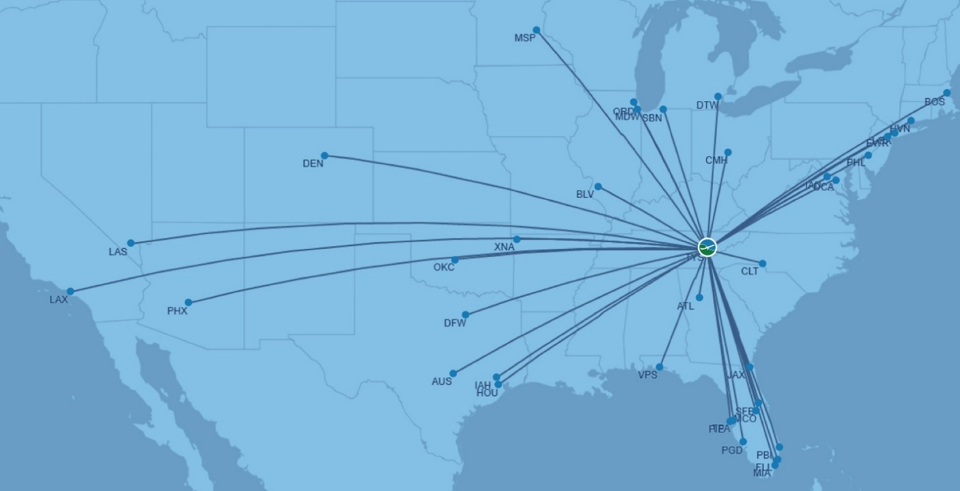
Source: Cirium Diio Mi.
Between 2015 and 2024, passenger traffic at TYS nearly doubled, marking a decade of sustained growth driven by new routes and expanded air service. As shown in Figure 1‑2, traffic increased steadily beginning in 2015, rising by 45 percent through 2019. Although passenger volumes dropped sharply in 2020 due to the COVID‑19 pandemic, traffic fully rebounded by 2023, when the airport served more than 2.8 million passengers - a new record. By the end of 2023, passenger volumes exceeded pre‑pandemic levels and grew further in 2024 with the launch of multiple new routes by existing carriers and the entry of Avelo Airlines into the TYS market.
Figure 1-2: Enplaned/Deplaned passengers at TYS, 2015-2024
Source: The Metropolitan Knoxville Airport Authority (MKAA) Site Statistics (2015-2024).

Air cargo services at TYS consist of dedicated cargo operations, including freighters and integrators, as well as belly‑hold capacity on commercial passenger flights. Figure 1‑3 illustrates historical air cargo volumes at TYS based on airport statistics. In the five years preceding the pandemic, the airport handled an average of approximately 82 million pounds of enplaned and deplaned cargo annually. Although passenger traffic declined by 55 percent between 2019 and 2020 due to the COVID‑19 pandemic, air cargo volumes remained resilient and peaked at about 89 million pounds, driven by increased e‑commerce activity, medical shipments, and supply‑chain disruptions.
Post‑pandemic normalization followed, with volumes declining to pre‑pandemic levels in 2022–2023 and further softening in 2024 to approximately 70 million pounds, reflecting modest shifts toward surface transportation and integrator network optimization rather than dedicated air cargo movements. Overall, air cargo performance throughout the last 10 years indicates that TYS enjoys a mature and reliable regional cargo operation that plays a crucial role in connecting out of state customers and firms to East Tennessee’s logistics and industrial base.

Figure 1-3: Enplaned/Deplaned Air Cargo at TYS, 2015-2024

Source: The Metropolitan Knoxville Airport Authority (MKAA) Site Statistics (2015-2024).

Core Catchment Area
Knoxville McGhee Tyson Airport is located in Blount County, with a large share of its market contained within the core economic and population centers which comprise the Knoxville MSA. However, as the 3rd largest commercial passenger airport in state, its overall catchment area more broadly includes a significant portion of Eastern Tennessee as outlined in Figure 1-4. McGhee Tyson Airport is also a regional hub serving demand beyond Tennessee, in particular extending into the western portion of North Carolina, reaching communities West of Asheville, NC. For the purposes of this study and the economic impacts generated, we only consider TYS’s ongoing economic impact within the state of Tennessee.

Figure 1-4: TYS Knoxville Tennessee Catchment Area
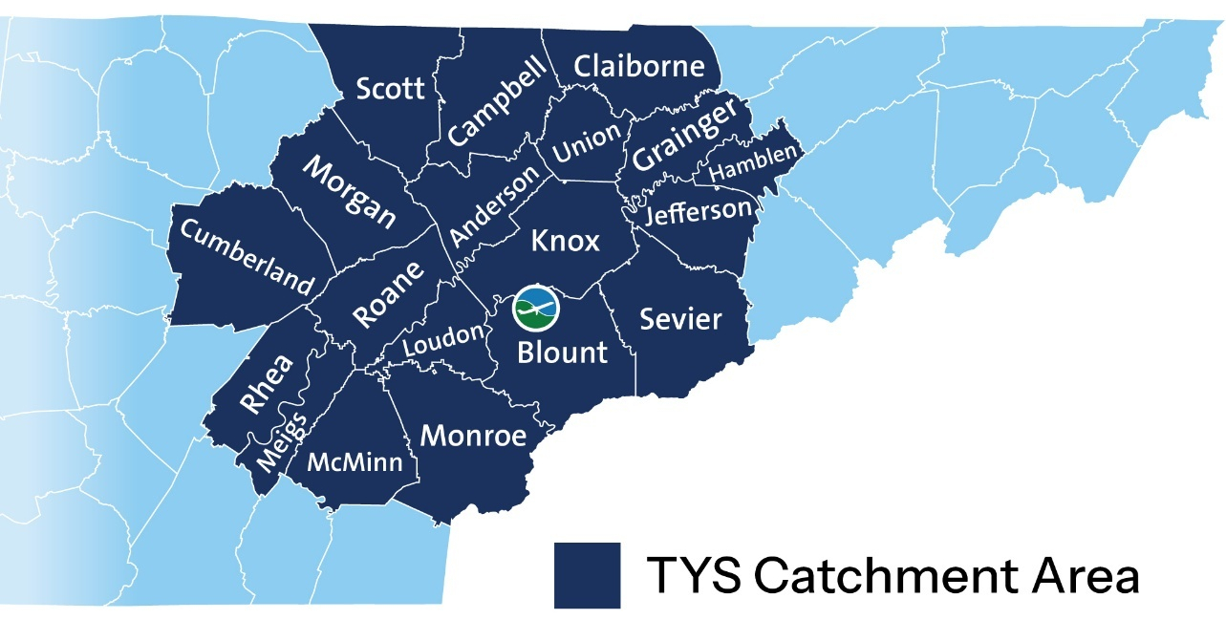
Source: The Metropolitan Knoxville Airport Authority (MKAA)

Overview of Economic Impact
Economic impact is a measure of the spending and employment associated with a sector of the economy, a specific project (e.g. the construction of a new facility), or a change in government policy or regulation. This study focuses on the employment and spending associated with McGhee Tyson Airport.
Economic impact is commonly measured using several metrics including employment, labor income, Gross Domestic Product (GDP), and economic output, all of which are defined in Figure 1-5. These measures help express the gross level of economic activity being generated by the airport. The economic benefits of the airport are highlighted by both the employment and income supported by the airport as well as the impacts on the broader economy through the production of GDP and economic output.
Figure 1-5: Measures of Economic Impact
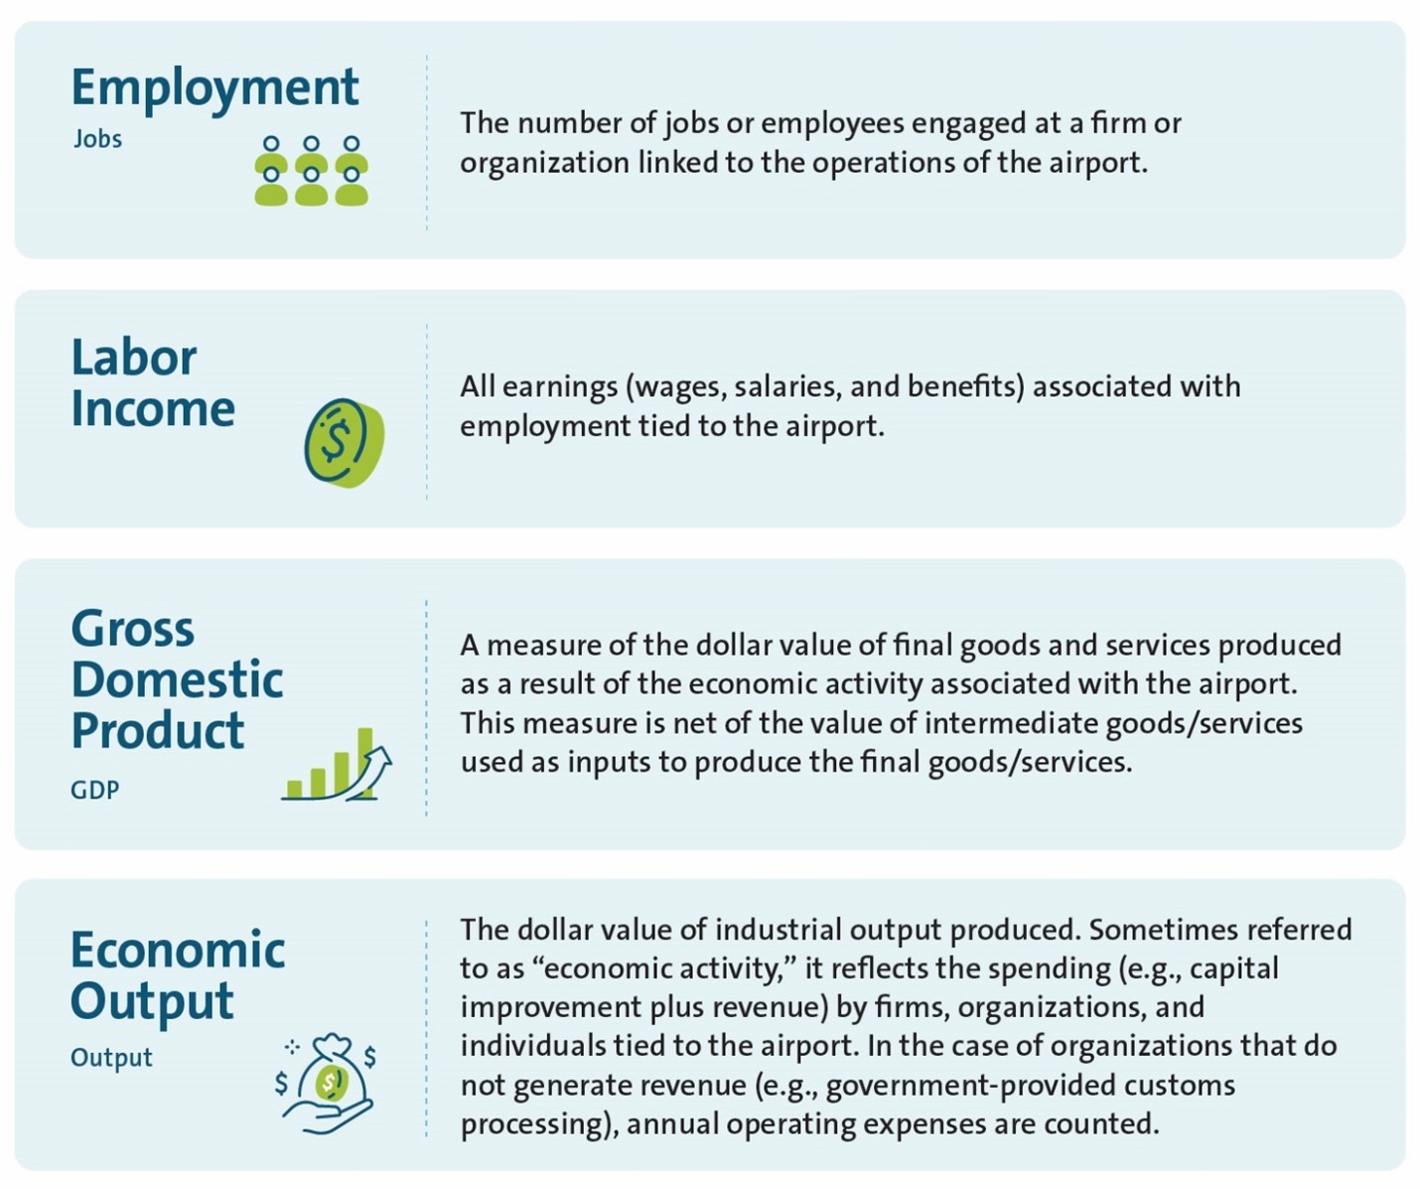

How Airports Generate Economic Impacts
This study measures three main ways in which TYS generates or facilitates economic impact: 1) ongoing airport operations, 2) airport capital improvement projects, and 3) visitor spending.
- Airport Operations. This reflects all aviation and related activities associated with running the airport and onsite businesses by airport tenants.
- Airport Capital Improvements. Includes the construction activity associated with infrastructure improvements made at the airport. Capital improvements at TYS are considered separately from regular airport operations as they generate one-time economic impacts and can vary over time and on a project-by-project basis.
- Visitor Spending. This measure accounts for the tourism-related economic impacts facilitated by the airport by bringing non-local air visitor traffic into the region to spend money on local businesses (namely food, accommodations, ground transportation, entertainment, and retail).

Categories of Economic Impact
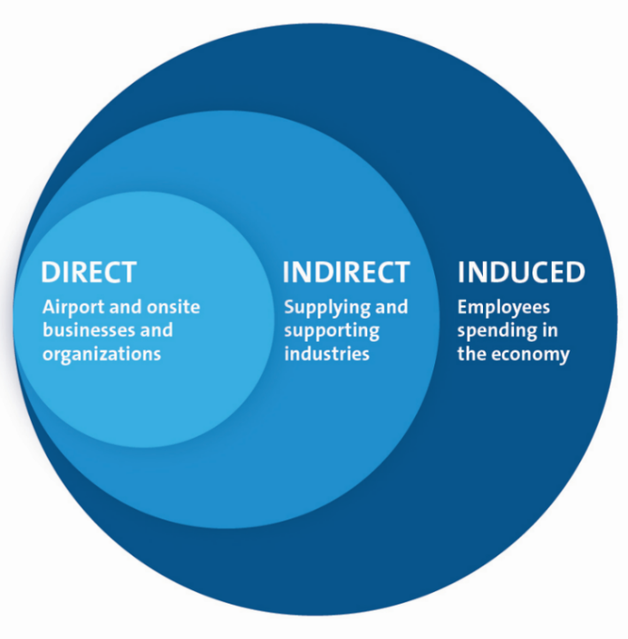
The three major levels of economic impact are classified as direct, indirect, and induced impacts. Airport operations, airport capital improvements, and visitor spending each generate their own set of these impacts. When combined, these classifications constitute the total economic impact of McGhee Tyson Airport. Each level of economic impact requires different tools of analysis. The direct, indirect, and induced employment, labor income, GDP, and output generated or facilitated by the airport are examined to produce a snapshot of the airport’s economic footprint.
Figure 1-6:
Categories of Economic Impact Generated and Facilitated by TYS

Direct Impact
Direct impacts account for the economic activity of the target sector itself. In the case of airport operations, the direct impacts cover the employment, labor income, GDP, and economic output that can be attributed to the operation and management of the airport, including all onsite businesses/tenants as well as any offsite activities that are directly involved in running the airport. In terms of the direct employment impact, this would include all personnel working at TYS such as airport management staff, employees of the fixed-based operator (FBO), private and corporate flight crews, aircraft maintenance and avionics technicians, flight instructors, medevac staff, etc.
Direct employment impacts of airport capital improvements include construction workers, contractors, engineers, and anyone else directly involved in an airport construction project.
Direct employment impacts of visitor spending include a portion of employees at hotels, restaurants, shops, and other hospitality businesses throughout the region where visitors arriving via TYS spend their money. Without these expenditures, fewer employees at these businesses would be needed to serve the incremental visitors facilitated by TYS.

Indirect Impact
Indirect impacts occur because of the direct impacts. This involves employment, labor income, GDP, and economic output generated by supplier industries that support airport operations, airport capital improvements, and the tourism-related businesses serving visitor traffic. In the case of airport operations specifically, the indirect impacts are generated in industries that supply or provide goods and services to the aviation industry. This may include oil refineries for jet fuel, parts suppliers for aircraft maintenance, accounting and legal service providers for airport tenants, etc.
Indirect impacts also stem from the direct impacts associated with capital improvements and visitor spending. For example, suppliers sell tools used for the construction of capital improvements at the airport, and food wholesalers supply goods to restaurants where out-of-state visitors spend their money.

Induced Impact
Induced impacts are created by the spending of wages, salaries, and profits earned from direct and indirect economic activities. They capture the economic activity generated by the employees of firms directly or indirectly connected to TYS spending their wages in the general economy. For example, if an aircraft maintenance engineer working at TYS – or a construction worker involved in the runway extension project, or a manager at a hotel serving visitors from TYS – spends his/her wages on groceries, restaurants, childcare, dental services, home renovations, and other items, this spending in turn generates employment in a wide range of sectors throughout the general economy. Induced impact is often called the “household spending effect”.

Total Impact
Total impacts are the sum of the direct, indirect, and induced impacts collectively associated with ongoing airport operations, capital improvements, and visitor spending.

Methodology
This chapter summarizes the methodology and sources referenced to estimate the economic impact of McGhee Tyson Airport.

Data Collection and Assumptions
Economic impact analysis depends on comprehensive data that accurately captures the direct economic activity or industry under evaluation. To support this assessment, primary information was collected through two survey mechanisms and further refined with information provided by the airport authority and major airport tenants.

Airport Employment Survey
The first step in the analysis is measuring the direct employment base associated with McGhee Tyson Airport’s ongoing operations, as job figures are more easily understood and accurately reported than financial data. This approach also reduces the risk of double counting, thereby providing a clearer assessment of the airport’s economic impact.
The employment survey was distributed to all businesses operating within the airport’s catchment area. The information collected helped develop a clear understanding of airport operations required to estimate the employment base associated with airport-related activities. The questionnaire was distributed to tenants and businesses via e-mail and collected the following information:
- Type of business/activity
- Employee headcounts and working hours
- Payroll and average wages
- Proportion of revenue or activity associated with airport operations
Employment attributable to ongoing activity at the airport was measured by surveying 48 businesses involved in airport operations. In total, almost 80% of the businesses contacted responded to the survey, including the largest employers at the airport, representing 95% of the overall direct job estimates related to airport operations. For non-responding firms, employment was estimated by referencing alternative data sources, such as airport security badge counts shared by MKAA, publicly available business information, and survey results from similar businesses.

Visitor Intercept Survey
The impacts of visitor spending were assessed though a visitor intercept survey administered in 2025 from July 29th to August 3rd. In total, 437 individuals were surveyed either on behalf of themselves or their party. The survey covered the following information:
- Departing Flight information
- Place of residence
- Purpose of trip, party size, length of stay, accounting for movement within the state.
- In state spending on accommodation, transportation, retail, food and beverage, entertainment and other activities

General Aviation Survey
McGhee Airport Tyson’s fixed base operators (FBOs) and air taxi operators provided data on General Aviation (GA) activity at the airport, with a particular focus on transient (non-local) traffic information to help estimate the number of GA visitors. Respondents provided detailed aviation activity data including estimates on the share of itinerant traffic attributable to non-local visitors, average passengers per transient aircraft arrival, as well as GA visitor characteristics such as average trip length and purpose.

Supplementary Data and Analysis
Additional data related to airport activity was provided by MKAA along with supporting information compiled by the project team from sources such as the U.S. Department of Transportation (US DOT), the Federal Aviation Administration (FAA), Sabre Global Demand Database, and federal and local tourism agencies. This data was used to estimate certain aspects of direct activity such as the following:
- Ground Transportation Employment – In addition to onsite tenants providing car rentals, vehicle parking, and shuttle services, the airport is supported by a large network of taxis, transportation network companies (e.g. Uber, Lyft), and other drivers who account for a large share of paid trips to and from McGhee Tyson Airport. MKAA provided detailed ground transportation trip statistics by commercial operators which were used to estimate driver hours and the overall employment associated with for-hire ground transport serving the airport.
- Airport Capital Expenditures – MKAA provided historical and planned expenses related to its capital improvement program for McGhee Tyson Airport, including annual expenditures and the estimated proportion which was spent within the state of Tennessee.
- Commercial Service Visitor Traffic – The annual number of commercial service visitors flying into TYS was developed using the US DOT Origin-Destination (O&D) and Sabre O&D databases to specify the proportion of TYS’s commercial passengers attributable to non-connecting, inbound (i.e. visitor) traffic.
- Average Expenditure by GA Visitor – Because the inherent nature of general aviation activity presents challenges to directly surveying these types of travellers, average visitor spend rates were instead modelled using public local data on key categories of expenditure (e.g. hotel Average Daily Rates (ADRs), ground transport rates, etc.) and corroborated with broader data on Knoxville tourism. Key information sources include the federal General Services Agency (GSA) local per diem data for Knoxville, local ground transport rates, Knoxville hospitality benchmarks by travel industry sources, and tourism statistics by Knoxville’s destination marketing organization, Visit Knoxville. The average trip spend calculated utilized these inputs in conjunction with the average trip length and trip type reported by the FBOs as previously described in the general aviation survey.

Estimating Multiplier Impacts
The direct inputs described in the previous section, specifically, airport employment, capital expenditures, and visitor spending, served as the key inputs for the IMPLAN model to estimate the broader economic impacts throughout Tennessee. This includes indirect and induced effects, as well as other direct measures not directly captured in the surveys, such as GDP and economic output.
IMPLAN is a widely recognized economic model that identifies interconnections within a regional economy and quantifies the effects of economic activity. It is constructed from numerous data sources, including the Bureau of Economic Analysis (BEA) Benchmark Input-Output (I-O) tables, the Bureau of Labor Statistics (BLS) Quarterly Census of Employment and Wages, the U.S. Census Bureau, and the U.S. Department of Agriculture.
The multipliers applied in this study are based on IMPLAN’s 2023 Input-Output data for each county in the State of Tennessee. All multipliers and economic ratios were adjusted to 2024 price levels, without assuming structural changes in the economy.
To estimate statewide impacts, IMPLAN’s Multi-Regional Input-Output (MRIO) analysis was employed. This method first calculates the indirect and induced impacts within the airport’s catchment area, then extends the analysis to the indirect and induced impacts occurring outside the catchment, but elsewhere in the state. This approach follows IMPLAN’s recommended methodology and provides a more precise estimation of total statewide economic effects than using aggregated state-level multipliers.

Estimating Tax Impacts
A related part of the economic impact associated with TYS includes the volume of tax revenues generated for federal, state, and local governments. Direct employment impacts generate tax revenue to public treasuries, and there are other taxes levied locally and by the state. The supply chain also contributes to government revenues, as does employment is supported via the ripple effects of indirect and induced economic activity.
The IMPLAN model was used to estimate the tax revenues associated with airport operations, airport capital improvements, and visitor spending. The tax impacts include revenues going to the federal as well as state and local governments and are representative of all estimated tax revenues generated by direct, indirect, and induced employment and business activity.

Note on Rounding and Dollar Figures
The results in this report are portrayed using rounded numbers, since economic impact values are estimates rather than precise audit or accounting figures. Unless stated otherwise, all monetary amounts are reported in 2024 dollars.

Economic Impact of Airport Operations
This chapter outlines the direct, indirect, induced, and total impacts of McGhee Tyson Airport’s ongoing operations. Additional impacts related to capital improvement projects and visitor spending are addressed in the following chapters.

Direct Impacts of Airport Operations
The direct impacts are those attributed to employment located on airport property or otherwise directly involved in airport operations. The direct employment of McGhee Tyson Airport’s ongoing operations is the sum of airport staff and all airport tenants’ employees, as collected and reported by airport management.
Using direct employment figures as inputs, the direct labor income, GDP, and economic output
impacts were then estimated using the IMPLAN model.

Direct Impacts of Airport Operations
Through its ongoing operations, McGhee Tyson Airport contributes directly to employment and the regional economy. It also acts as an economic catalyst, facilitating the growth of regional businesses and communities. Every flight and every aircraft serviced at the airport facilitates employment hours related to handling the aircraft and any accompanying passengers. This employment includes flight crew and flight instructors, airport management and FBO staff, air traffic controllers, aircraft maintenance and avionics technicians, medevac personnel, and any support staff for activities located at the airport.
Figure 3-1 summarizes the direct impacts of ongoing operations at McGhee Tyson Airport in 2024. Altogether, ongoing airport operations directly supported 3,300 jobs that paid $259 million in earnings, providing an average income of about $78,000 per job. This exceeds the average annual Tennessee state wage of $66,500 and the average national wage of $73,200 in 2024.
In addition to employment and wages, the airport directly contributed $464 million in GDP and $676 million in economic output in 2024.
Figure 3-1: Direct Impacts of TYS Airport Operations, 2024
 |  |  |  | 
Impact | Employment  (Jobs) | Labor Income  ($ Millions) | GDP  ($ Millions) | Output  ($ Millions)
Direct | 3,300 | $259 | $464 | $676

Direct Employment by Business Type at TYS
The direct employment associated with ongoing operations at McGhee Tyson Airport is broken down and presented by business type in Figure 3-2. The military is by far the largest employer at McGhee Tyson Airport, representing a significant portion of the overall employment at the airport. Other major employers involved in the ongoing operations of McGhee Tyson Airport include FBOs, aircraft maintenance firms, and air passenger carriers.

Figure 3-2: Direct Employment at TYS by Business Type, 2024
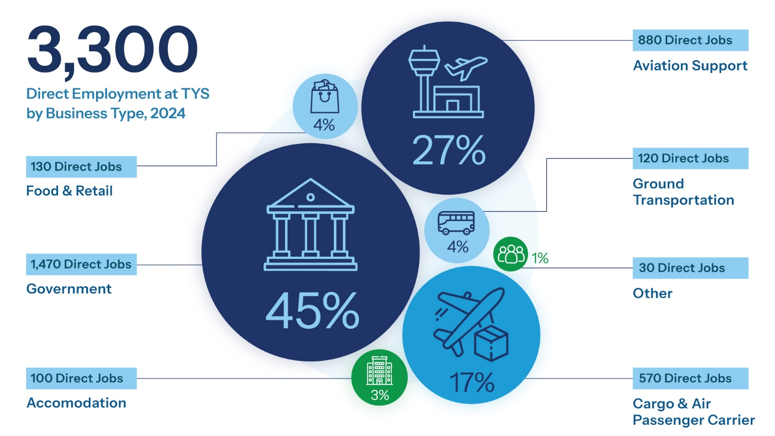
Accommodations

The business categories shown above can be summarized as follows:
- Government accounts for employment related to the military and other government agencies such as TSA who operate at McGhee Tyson Airport. This category accounts for roughly 1,470 jobs, or 45% of total onsite employment.
- Aviation Support includes the employment related to FBO, aircraft maintenance charter activity and aviation training. This category accounts for 880 jobs (27% of direct employment).
- Cargo & Air Passenger Carrier reflects the scheduled passenger service and dedicated cargo operations taking place at McGhee Tyson Airport. These operations account for 570 direct jobs, or 17% of the total direct onsite employment.
- Food & Retail includes employment related to the provision of food and retail concession services. Firms in this category employ about 130 jobs, or 4% of direct employment.
- Ground Transportation includes activity associated with on-airport car rental firms and for-hire passenger transportation services such as taxis, limos, and TNCs. This represents 120 jobs (4% of direct employment).
- Other captures smaller uncategorized businesses operating at the airport, which represent only 30 jobs or under 1% of total direct employment.

Indirect and Induced Impacts of Airport Operations

Indirect Impacts of Airport Operations
Indirect effects include the activity of companies that support direct airport operations. For example, this includes the segment of employment in supplier industries that rely on sales to the air transport sector, such as oil refineries that provide jet fuel.
In 2024, McGhee Tyson Airport’s operations supported 880 indirect jobs that paid $64 million in labor income (see Figure 3-3). This activity generated $85 million in indirect GDP and $157 million in indirect economic activity
Figure 3-3: Indirect Impacts of TYS Airport Operations, 2024
Impact | Employment  (Jobs) | Labor Income  ($ Millions) | GDP  ($ Millions) | Output  ($ Millions)
Indirect | 880 | $64 | $85 | $157

Induced Impacts of Airport Operations
Induced impacts are those created by the spending of wages, salaries, and profits earned in direct and indirect economic activities. These are the “ripple effects” or “household spending effects” of successive rounds of spending throughout the broader state economy. Induced employment, for example, is employment generated from the expenditures by individuals employed directly or indirectly from airport operations. Induced effects typically reflect changes in spending from households as income increases or decreases due to the changes in production (in this case, airport operations).
As shown in Figure 3-4, McGhee Tyson Airport’s operations supported 1,390 induced jobs that paid $85 million in earnings. This activity amounted to $157 million in GDP and $252 million in economic activity.
Figure 3-4: Induced Impacts of TYS Airport Operations, 2024
Impact | Employment  (Jobs) | Labor Income  ($ Millions) | GDP  ($ Millions) | Output  ($ Millions)
Induced | 1,390 | $85 | $157 | $252

Total Economic Impact of Ongoing Airport Operations
Ongoing McGhee Tyson Airport operations, including multiplier (indirect and induced) effects, supported over 5,560 jobs and $408 million in wages in 2024. Including multiplier impacts, operations at the airport also contributed over $706 million in total GDP and $1,085 million in total economic output for the state, as shown in Figure 3-5.
Figure 3-5: Total Economic Impact of TYS Airport Operations, 2024
Impact | Employment  (Jobs) | Labor Income  ($ Millions) | GDP  ($ Millions) | Output  ($ Millions)
Direct | 3,300 | $259 | $464 | $676
Indirect | 880 | $64 | $85 | $157
Induced | 1,390 | $85 | $157 | $252
Total | 5,560 | $408 | $706 | $1,085

Economic Impact of One-Time Airport Capital Improvements

Capital Improvements in 2024
Annual capital investments at TYS reflect major infrastructure developments needed to keep the airport functional as well as to accommodate anticipated future growth in activity at the airport. Each capital improvement project generates additional economic impacts beyond regular daily airport operations as previously described.
From fiscal years 2023 through 2025, MKAA estimates a total spending of $188 million (an annual average of $63 million, expressed in 2024 dollars) spent on capital improvements at McGhee Tyson Airport. The summarized expenditures occur within the state of Tennessee, generating economic impacts throughout the local and statewide economies. A small portion of capital improvement expenditures was excluded as this spending occurred outside of Tennessee. In 2024, MKAA launched their new capital improvement program, Flight Plan, which includes expansions to the concourse, parking garage, concessions, TSA Checkpoint Security and ticket counters. The project will also replace terminal building escalators. In 2025, the airport completed the expansion of the east and west ramp.
As shown in Figure 4-1, capital spending in 2024 alone supported 440 direct jobs that generated $32 million in direct earnings as well as $33 in direct GDP and $63 million in direct economic output. Including multiplier effects, the average annual capital spending at McGhee Tyson Airport supported a total of 710 jobs earning 49 million in wages, with a total contribution of $65 million in GDP and over $117 million in economic output.
Figure 4-1: Total Economic Impact of TYS Capital Improvements, 2024
Impact | Employment  (Jobs) | Labor Income  ($ Millions) | GDP  ($ Millions) | Output  ($ Millions)
Direct | 440 | $32 | $33 | $63
Indirect | 100 | $8 | $13 | $24
Induced | 170 | $10 | $19 | $31
Total | 710 | $49 | $65 | $117

Economic Impact of Visitor Spending

Visitor Spending
Another related economic impact that arises from the airport’s operations flows from off-airport spending by visitors to Tennessee who arrive via McGhee Tyson Airport. The hospitality industry in particular benefits from these visitors who spend money on lodging, meals, entertainment, local ground transportation, and shopping. The economic impacts associated with visitor spending include a distinct set of direct, indirect, and induced impacts which are separately identified in this report, with careful attention paid to ensure that the economic impacts associated with tourism do not overlap with the economic impacts of airport operations.

Air Visitor Profile
It is estimated that there were nearly 750,000 visitors who arrived in Tennessee via commercial flights at McGhee Tyson Airport, accounting for nearly 45% of all commercial enplanements at TYS in 2024. In addition, approximately 80,000 visitors flew into McGhee Tyson Airport on general aviation (GA) flights in 2024, accounting for a small share of overall air visitors given the fact that GA operations are a small share of traffic at TYS and generally use smaller aircraft than scheduled commercial service. Visitors arriving on commercial versus GA service often exhibit different trip characteristics and spending profiles, as summarized in Figure 5-1 below. On average, GA visitors tend to travel more often for business purposes relative to commercial passengers, and while they have a higher propensity to spend, they generally have shorter trip lengths overall.
In total, expenditures in Tennessee by visitors arriving via TYS amounted to over $873 million in 2024
Figure 5-1: TYS Commercial Air Visitor Spending, Avg. Per Visitor Spend (Trip Total), 2024
Spend Category | Domestic  Visitor | International  Visitor
Accommodation | $406 | $495
Local Ground Transportation | $161 | $297
Food | $349 | $404
Retail | $74 | $215
Attractions | $116 | $167
Other | $4 | $0
Total | $1,110 | $1,579

Importantly, GA visitors and commercial visitors tend to vary in terms of visitation and spending profiles. Figure 5-2 contrasts the visitor profiles of GA visitors to Tennessee through TYS. This information provides important parameters for understanding potential spending rates and patterns for this visitor market.
Figure 5-2: TYS General Aviation Air Visitor Profile, 2024
 | Air Service |  | Number of Visitors |  | Trip Purpose | Avg.  Person-Trip  (Nights) |  | Avg. Per Visitor Spend  (Trip Total) |  | Avg. Per Visitor Spend  (per Night) |  | Total Expenditures (Millions)
Commercial |  | 749,845 |  | 36% Business / 64% Personal |  | 4.8 | $1,133 |  | $236 |  | $849
General Aviation |  | 80,337 |  | 50% Business / 50% Personal |  | 1 | $295 |  | $295 |  | $23.7
TOTAL |  | 830,182 |  |  |  |  |  |  |  |  | $873

Visitor Expenditure Impacts
The economic impact of non-local visitors who arrived via TYS are summarized below in Figure 5-3. In 2024, these air visitors supported 7,130 direct jobs that paid $295 million in wages, further generating $504 million in direct GDP and $798 million in direct output. Including the indirect and induced impacts, visitor spending supported a total of 10,280 jobs paying $497 million, along with $844 million in total GDP and $1,394 million in total output.

Figure 5-3: Economic Impact of Visitor Spending Facilitated by TYS, 2024
Impact | Employment  (Jobs) | Labor Income  ($ Millions) | GDP  ($ Millions) | Output  ($ Millions)
Direct | 7,130 | $295 | $504 | $798
Indirect | 1,470 | $99 | $149 | $290
Induced | 1,680 | $103 | $190 | $305
Total | 10,280 | $497 | $844 | $1,394
Note: Figures may not sum to totals due to rounding.

Consolidated Economic Impact of TYS
The total economic impact of McGhee Tyson Airport incorporates the impacts associated with ongoing airport operations, capital improvement projects at the airport, and spending from visitors who fly into the area via the airport. They include the impacts linked directly to each of these components, as well as the associated supply chain effects (indirect impacts) and the resulting household spending effects (induced impacts).

Summary of 2024 Economic Impact
As shown in Figure 6-1, the consolidated economic impact of TYS surpassed 16,560 total jobs with wages of $954 million, along with a total GDP contribution of $1,614 million and $2,596 million in total economic output
Figure 6-1: Consolidated Economic Impact of TYS, 2024
 | Impact | Employment  (Jobs) | Labor Income  ($ Millions) | GDP  ($ Millions) | Output  ($ Millions)
Airport Operations | Direct | 3,300 | $259 | $464 | $676
Airport Operations | Indirect | 880 | $64 | $85 | $157
Airport Operations | Induced | 1,390 | $85 | $157 | $252
Airport Operations | Total | 5,560 | $408 | $706 | $1,085
Capital Improvements | Direct | 440 | $32 | $33 | $63
Capital Improvements | Indirect | 100 | $8 | $13 | $24
Capital Improvements | Induced | 170 | $10 | $19 | $31
Capital Improvements | Total | 710 | $49 | $65 | $117
Visitor Spending | Direct | 7,130 | $295 | $504 | $798
Visitor Spending | Indirect | 1,470 | $99 | $149 | $290
Visitor Spending | Induced | 1,680 | $103 | $190 | $305
Visitor Spending | Total | 10,280 | $497 | $844 | $1,394
Consolidated | Direct | 10,880 | $585 | $1,002 | $1,537
Consolidated | Indirect | 2,440 | $170 | $247 | $471
Consolidated | Induced | 3,240 | $199 | $365 | $588
Consolidated | Total | 16,560 | $954 | $1,614 | $2,596
Note: Figures may not sum to totals due to rounding.

Tax Impacts

Tax Impacts
A related part of McGhee Tyson Airport’s economic impact includes the significant amount of tax revenue generated for federal, state, and local governments. Direct employment impacts involve millions of dollars of tax revenue to public treasuries, and there are other taxes levied locally and by the State of Tennessee. The supply chain also contributes to government revenues, as does employment is supported via the ripple effects of indirect and induced economic activity.
Tax revenue contributions include the following categories based on the IMPLAN model:

Federal Taxes
- Personal Taxes. This category contains the personal income tax impacts generated by households linked to McGhee Tyson Airport and payable at the federal level.
- Other Taxes and Fees. This category includes corporate profits taxes and other business-paid taxes on production and imports, net subsidies, such as excise and customs taxes. In addition, this category includes employee and employer contributions to federal social insurance taxes.

State and Local Taxes
- Property Taxes. This category contains all property taxes paid by either households or businesses.
- Sales Taxes. This category contains all state and local sales taxes.
- Other Personal Taxes. Excluding property taxes (noted separately above), this category contains other taxes and fees paid by households at the state and local level. Given that Tennessee does not have a state income tax, this category includes relatively minor amounts related to motor vehicle licensing fees, fishing and hunting licensing fees, and other applicable taxes.
- Other Taxes and Fees. Excluding property and sales taxes (noted separately above), this category includes other business-paid taxes on productions and imports, net of subsidies, at the state and local levels including motor vehicle licensing fees, severance taxes, as well as other taxes and special assessments. In addition, this category includes employee and employer contributions to state social insurance taxes.
Figure 7-1 summarizes the estimated federal, state, and local tax revenues generated via airport operations, capital improvements, and visitor spending. Altogether, total tax revenues attributable to TYS (including direct, indirect, and induced impacts) reached nearly $383 million in 2024. Approximately 58% of this was attributable to contributions to the federal government while 30% went toward state revenues, primarily through state sales taxes. The remaining 12% percent was attributable to local revenues.
Figure 7-1: TYS Tax Impacts, 2024
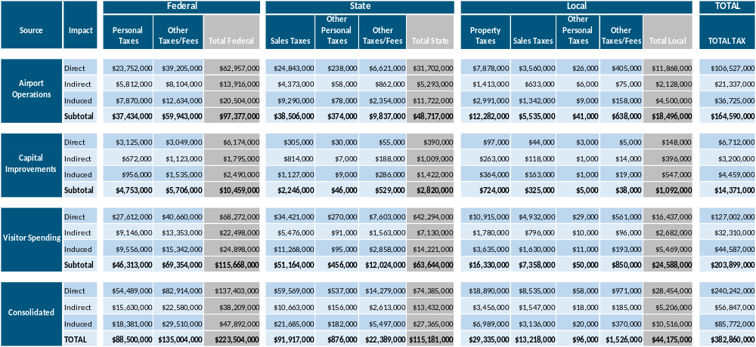
Note: Figures shown are rounded to the nearest thousand. Figures may not sum to totals due to rounding.

Appendix A: Glossary of Terms
Direct Employment: Direct employment is employment that can be directly attributable to the operations in an industry, firm, etc. It is a literal head count of those people who work in a sector of the economy.
Economic Activity: (also Output, Production) The end product of transforming inputs into goods. The end product does not necessarily have to be a tangible good (for example, knowledge), nor does it have to create utility (for example, pollution). Or, more generally, the process of transforming the factors of production into goods and services desired for consumption.
Economic Output: (also Economic Activity, Production) The end product of transforming inputs into goods. The end product does not necessarily have to be a tangible good (for example, knowledge), nor does it have to create utility (for example, pollution). More generally, it is defined as the process of transforming the factors of production into goods and services desired for consumption.
Employment Impact: Employment impact analysis determines the economic impact of employment in terms of jobs created and salaries and wages paid out. In the case of the airport, the direct, indirect, induced and total number of jobs created at the airport is examined to produce a snapshot of airport operations.
Gross Domestic Product: (GDP, also value-added) A measure of the money value of final goods and services produced as a result of economic activity in the nation. This measure is net of the value of intermediate goods and services used up to produce the final goods and services.
Indirect Employment: Indirect employment is employment which results because of direct employment. For the airport, it would include that portion of employment in supplier industries which are dependent on sales to the air transport sector. In some cases, contract work would be considered indirect employment.
Induced Employment: Induced employment is employment created because of expenditures by direct and indirect employees.
Multiplier Analysis: Analysis using economic multipliers in which indirect and induced economic impacts are quantified. Essentially, a multiplier number is applied to the "directly traceable economic impact" to produce indirect and total effects (see Multiplier).
Multiplier: Economic multipliers are used to infer indirect and induced effects from a particular sector of the economy. They come in a variety of forms and differ in definition and application. A multiplier is a number which would be multiplied by direct effects to calculate indirect or induced effects. In the case of the airport, as in many other cases, multipliers can lead to illusory results, and thus must be used with great care.
Tenant: A firm which pays a lease to a leasing company or to the airport authority directly.
Value-Added: (also GDP) A measure of the money value of final goods and services produced as a result of economic activity in the nation. This measure is net of the value of intermediate goods and services used up to produce the final goods and service.


Prepared by
InterVISTAS Consulting USA LLC
1701 Rhode Island Ave, NW
Washington, DC 20036
USA

Telephone: +1-202-688-2220

www.intervistas.com

Indirect impacts result from the direct impacts and involve employment in upstream industries (suppliers) that depend upon activities at TYS. Induced impacts are generated from spending by the direct/indirect employees and businesses.
U.S. Bureau of Labor Statistics, Unemployment Rates for Metropolitan Areas, Annual Averages.
Knoxville Chamber “2025 Knoxville Area Facts & Figures”, 2025 Facts and Figures Report 2025
https://flyknoxville.com/airport-authority/about/
McGhee Tyson Airport (TYS)
The indirect impacts of aviation can include some impacts associated with the hospitality industry. Similarly, the indirect impacts of tourism accounts can include aviation. Adjustments have been made to mitigate any double-counting in the overall economic impacts of airport operations and visitor spending.
IMPLAN makes use of regional averages per industry to estimate tax impacts.
U.S. Bureau of Economic Analysis.

